Q2. Solve the following
1. Retrieve the details (Name, Salary and dept no) of the emp who are working in
department code 20, 30 and 40.
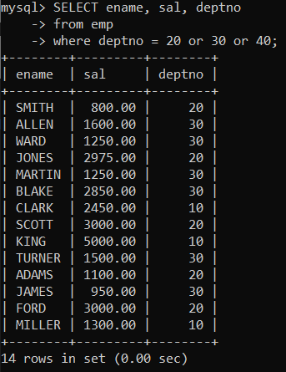
2. Display the total salary of all employees . Total salary will be calculated as
sal+comm+sal*0.10
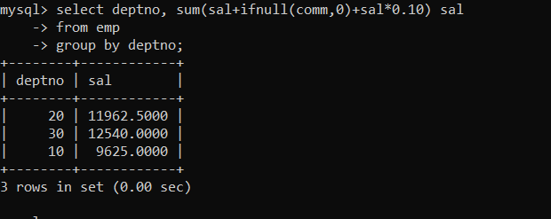
3. List the Name and job of the emp who have joined before 1 jan 1986 and whose
salary range is between 1200and 2500. Display the columns with user defined Column
headers.
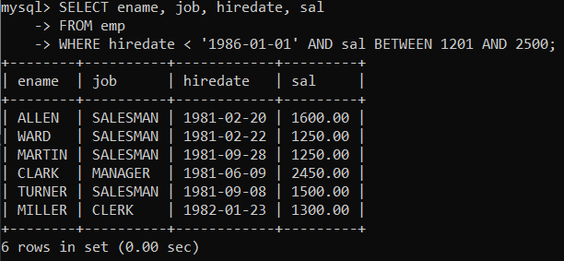
4. List the empno, name, and department number of the emp works under manager
with id 7698.
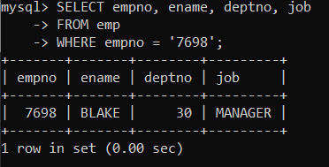
5. List the name, job, and salary of the emp who are working in departments 10 and
30.
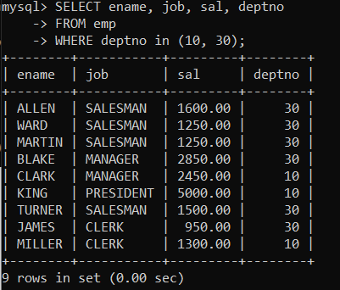
6. Display name concatenated with dept code separated by comma and space. Name
the column as ‘Emp info’.
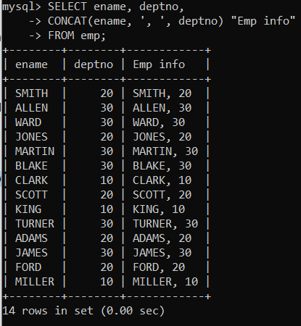
7. Display the emp details who do not have manager. 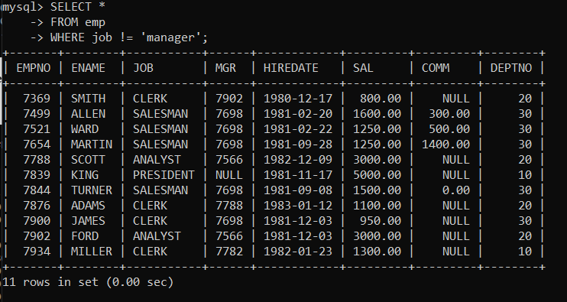
8. Write a query which will display name, department no and date of joining of all
employee who were joined January 1, 1981 and March 31, 1983. Sort it based on date of
joining (ascending).
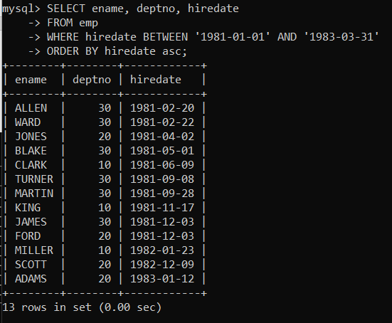
9. Display the employee details where the job contains word ‘AGE’ anywhere in the Job.
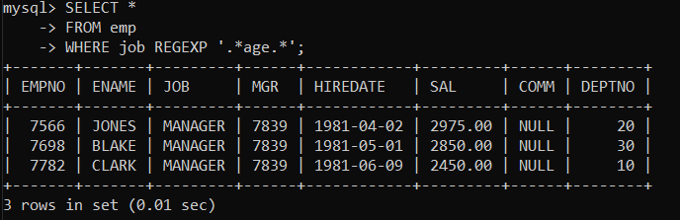
11. List the details of the employee , whose names start with ‘A’ and end with ‘S’ or whose names contains N as the second or third character, and ending with either ‘N’ or ‘S’.
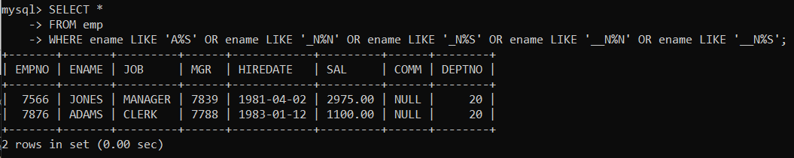
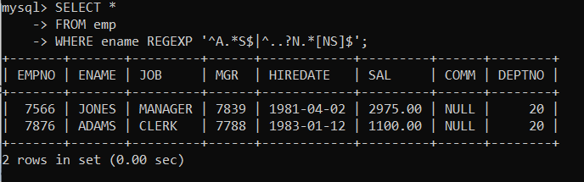

12. List the names of the emp having ‘_’ character in their name.

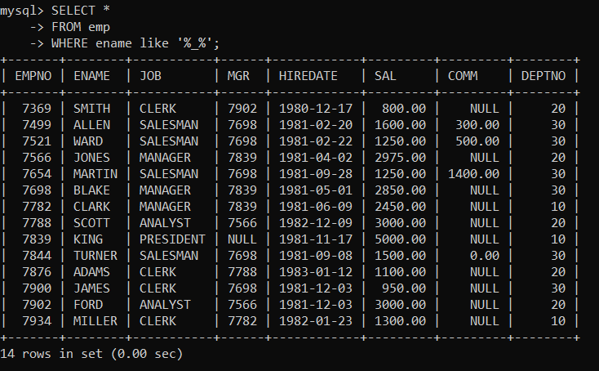
13. find 3rd highly paid employee
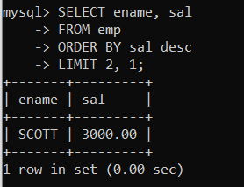
14. find employee who has earned highest commission
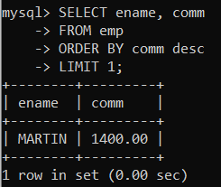
15. display ascii value of 1st character of job from emp
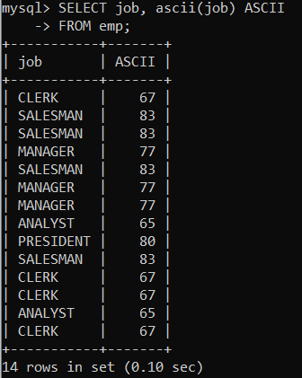
16. display empno,ename,job,code code should be 1 st 3 characters of ename and 1st 3 characters of job.
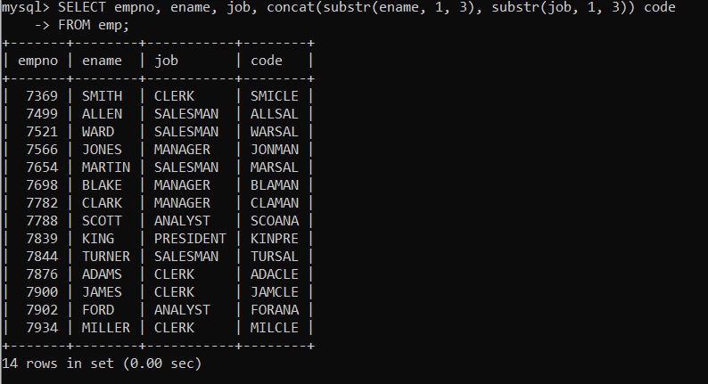

Single Row functions
1. To list all employees and their email, to generate email use 2 to 5 characters from ename
Concat it with 2 to 4 characters in job and then concat it with ‘@mycompany.com’.
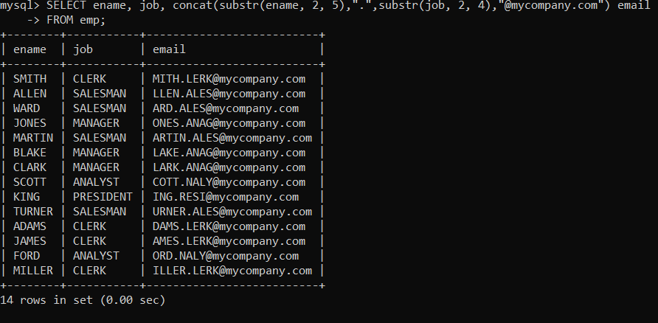
2. List all employees who joined in September.
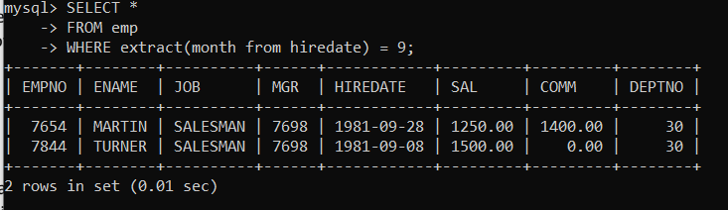
3. List the empno, name, and department number of the emp who have experience of 18 or
more years and sort them based on their experience.
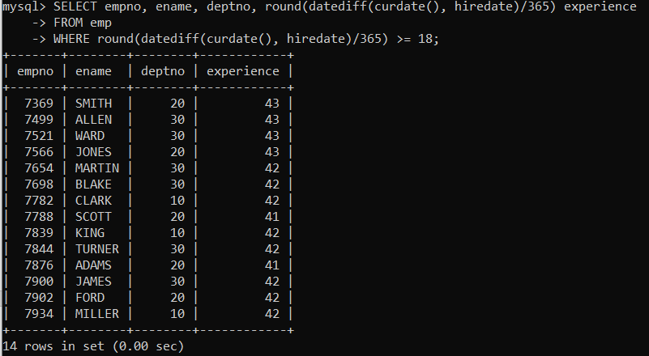
4. Display the employee details who joined on 3rd of any month or any year
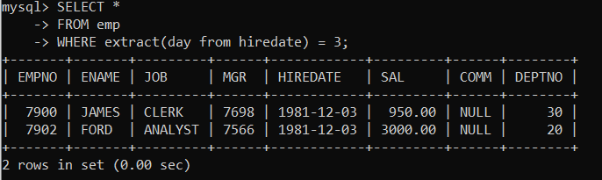

5. display all employees who joined between years 1981 to 1983.
